Fall Detection Systems in Public Spaces
Eden Amram, Ziv Shamli

Introduction
According to the World Health Organization (WHO), falls are the second leading cause of unintentional injury-related deaths worldwide. Each year, the WHO estimates that approximately 37.3 million individuals experience falls severe enough to require medical attention, underscoring the substantial global health burden associated with this issue. National-level data support this observation: a 2024 study titled Clinical trauma severity of indoor and outdoor injurious falls requiring emergency medical service response reported that in the United States alone, 1,854,909 fall incidents in 2019 required emergency medical services (EMS).
The study found that nearly 85% of fall events occur indoors, however, a meaningful proportion also occurs outdoors: in parks, sidewalks, and roadways. These outdoor environments introduce additional challenges such as uneven terrain, varying lighting conditions, environmental obstacles, and the presence of other people in the background. Such factors create complex real-world scenarios that significantly complicate fall-detection tasks.
A recent systematic review, Deep Learning for Computer Vision based Activity Recognition and Fall Detection of the Elderly (2024), further highlights major limitations in current research. Most existing fall-detection models achieve high performance only in controlled indoor environments, while their accuracy deteriorates in uncontrolled settings such as outdoor areas, crowded spaces, and low-light conditions. The review emphasizes that nearly all publicly available fall-detection datasets are collected in laboratory-controlled indoor environments, characterized by stable lighting, fixed camera positions, clean backgrounds, and scripted fall scenarios performed by healthy individuals. As a result, current datasets lack the visual diversity necessary for robust real-world generalization.
Additionally, the review notes that many proposed deep learning architectures are computationally heavy, making them impractical for real-time deployment, especially on resource-constrained edge devices. In real-world applications, fall-detection systems must operate with minimal latency to provide timely alerts, which requires lightweight and efficient models capable of real-time inference without sacrificing accuracy.
Developing such systems also requires large, diverse, and realistic datasets, covering a wide range of lighting conditions, backgrounds, camera angles, human appearances, and dynamic environments. However, collecting large-scale real-world fall data manually is impractical due to safety constraints, time limitations, and high costs. Consequently, recent research highlights the growing need to leverage generative models, such as diffusion-based architectures, to synthesize realistic and diverse fall-related images. These generative techniques can significantly augment existing datasets, increase visual variability, and improve the generalization and robustness of fall-detection models in real-world scenarios.

Related Works
There are various types of generative models for creating realistic images, including Text-to-Image models and models designed for integrating objects into existing images (Object Compositing). These models enable the generation of new, visually accurate images, whether based on textual descriptions or through object integration, while maintaining consistent details and a coherent scene. In this study, generative models were used to create realistic images of falls in public spaces, with the aim of producing data for training and evaluating fall detection models.
A comparative study conducted in “Perception and Evaluation of Text-to-Image Generative AI Models” examined the performance of four leading models: OpenAI’s DALL-E, Google’s Imagen, Stable Diffusion, and GROK AI. The study combined quantitative evaluation using metrics such as FID, SSIM, and PSNR with human evaluation in a survey of 28 participants, aiming to assess the perceived realism of the generated images.
DALL-E, based on a Transformer architecture with VQ-VAE-2 for creating a discrete latent space, showed high performance in both quantitative metrics and user evaluation, demonstrating the ability to generate diverse and complex images. Imagen, Google’s closed diffusion model, excelled in producing photorealistic and accurate images, with participants rating its outputs as nearly as realistic as real photographs. In contrast, open models such as Stable Diffusion and GROK showed lower performance, with higher FID scores and lower perceived realism.
In the context of object integration into existing images, the study by Song et al. (2024) introduced IMPRINT, an innovative Generative Object Compositing framework. The model focuses on preserving object identity and harmonizing with the background, applying a two-stage strategy: the first stage involves Context-Agnostic ID-Preserving Pretraining using a DINOv2-based encoder to learn view-invariant representations and preserve instance-level details; the second stage performs Compositing & Harmonization with fine-tuning of the Stable Diffusion UNet, including integration of the object embedding in cross-attention layers and additional techniques to improve harmonization and control object shape.
Experiments with IMPRINT showed superior performance compared to existing models such as Paint-by-Example, ObjectStitch, and TF-ICON. Quantitative metrics indicate significant advantages: FID = 16.45, indicating high realism; CLIP-score = 96.19, reflecting optimal object identity preservation; DINO-score = 94.71, showing precise visual detail retention; and DreamSim = 0.083, indicating close alignment with perceived realism by users. In a user survey, 73–86% preferred IMPRINT in terms of object fidelity and image realism.
From the analysis of the findings, several key trends can be identified: first, industrial Text-to-Image models (DALL-E, Imagen) exhibit high realism and diverse image generation capabilities; second, Object Compositing models allow realistic integration of objects while preserving their identity and scene consistency; third, combining quantitative evaluation with human assessment is essential for evaluating generative model performance; and finally, there is a significant gap between large industrial models and open models, particularly regarding realism and visual detail preservation.
There are different approaches to human fall detection, with some methods processing each frame individually, while others analyze a sequence of frames to detect abnormal movement patterns. The choice of approach affects not only the detection accuracy under challenging conditions, such as low lighting, complex backgrounds, or partial occlusions, but also the processing speed, which is critical for real-time applications on edge devices.
Zhang et al. (2022) in “Visual Surveillance for Human Fall Detection in Healthcare IoT” present a visual monitoring system designed for integration into healthcare IoT infrastructures. The system operates in two main stages: first, it tracks the person using motion detection and gait analysis. Second, it analyzes body posture by calculating angles, curvatures, and rapid changes in body position. The system uses a model such as OpenPose to detect body keypoints in each frame, which are then connected to form a skeleton representation. From the skeleton, features such as body angles, leg angles, and height–width ratio are computed to detect falls and abnormal postures. Advantages of this approach include robustness to background noise and partial occlusions, low dependency on color or texture, and high accuracy under good lighting conditions (up to 98.4%). Limitations include poor performance in low-light environments, high computational requirements (GPU), and the risk of false alarms, particularly in complex scenes.
Zi et al. (2023) in “Detecting Human Falls in Poor Lighting: Object Detection and Tracking Approach for Indoor Safety” focus on fall detection in low-light environments. The system includes preprocessing to isolate the body and reduce background noise, feature extraction using an object detection model (YOLO) to learn the appearance and current posture of the person in each frame, and a temporal model based on LSTM/GRU that analyzes a sequence of frames to understand movement: standing → losing balance → falling. Advantages of this approach include understanding movement over time, noise reduction, and higher accuracy compared to single-frame models. Limitations include higher computational requirements, the need to analyze multiple frames, and sensitivity to occlusions, for example, when the person is partially hidden behind furniture, accuracy decreases.
Nabizade et al. (2025) in “Fall Detection Using LBFD-Net: A Novel CNN-Based Architecture” introduce a lightweight CNN called LBFD-Net for real-time fall detection. The model was trained on a combined dataset of 18,316 labeled images from four different datasets, balanced between fall and non-fall images. The architecture includes convolutional and residual blocks, global average pooling to create a compact feature vector, and a fully connected layer with a sigmoid output to estimate the probability of a fall. The model achieved high accuracy (99.59%), low resource requirements, and was both lighter and more efficient compared to classical models such as AlexNet and LeNet. Limitations include processing single frames only (without temporal information), training only in controlled environments, and no training on low-light or outdoor images. In our study, we plan to use this network due to its high accuracy, lightweight design, and real-time capability on edge devices.
Research Question
How does training a fall detection model on images with varying lighting conditions (including darkened images) , indoor environment and crowded space affect the model’s accuracy, sensitivity, and robustness in detecting falls under different lighting environments?

Datasets:
- URFD
The dataset contains 289 fall images and 363 non-fall images (normal activities). The images were extracted from video sequences captured with RGB and Depth (Kinect) cameras. All samples were recorded indoors under bright and controlled lighting conditions.
Link: URFD Dataset
- UP-Fall
The dataset includes 17 participants (9 males, 8 females) aged 18–24. Each participant performed 11 activities (6 daily activities and 5 falls), each repeated three times. All recordings were captured with RGB cameras under bright and controlled lighting conditions.
Link: UP-Fall Dataset
- Le2i
The dataset contains 208 images from 13 different scenes. Half of the images (104) depict falls, and the other half (104) show normal activities. Images were captured in various environments (living rooms, meeting rooms, corridors, etc.) and from different angles. Lighting conditions were bright and controlled.
Link: Le2i Dataset
- MultiCam
The dataset includes 24 video clips of falls as well as videos of normal activities. Recordings were made simultaneously with 8 different cameras to capture events from multiple angles. All recordings were conducted under bright and controlled lighting, with variations in lighting angles only.
Link: MultiCam Dataset

Methodology
This research consists of two main phases.
Phase 1 focuses on evaluating generative models and creating a synthetic dataset representing public-space fall scenarios, addressing the lack of real-world outdoor fall data.
Phase 2 evaluates the performance and generalization capabilities of LBFD-Net under different training conditions, using both real laboratory data and synthetic data.

Phase 1: Generative Model Evaluation and Synthetic Dataset Creation
Due to the lack of publicly available real-world fall datasets collected in outdoor or crowded environments, this study first focused on generating synthetic fall images using advanced generative AI models. The goal was to identify the most suitable Text-to-Image and Image-to-Image models capable of producing realistic fall and non-fall scenes in public spaces such as streets, sidewalks, and parks.
Two evaluation tracks were conducted:
Track A: Text-to-Image
In this track, each model generated 10 images based on the same textual description of a fall event in a public space. The generated images were evaluated using a combination of physical and perceptual metrics, with primary emphasis on metrics reflecting physical consistency and 3D spatial coherence.
Physical Metrics (High Priority)
- Depth Consistency - Measures the spatial coherence of scene depth, particularly maintaining the relative positions of characters, background, and objects. This metric assesses whether body poses and falls are integrated logically within the 3D scene.
- Shading Consistency - Evaluates the alignment of shadows with scene lighting, including direction, intensity, and placement. This metric is critical for identifying physical inconsistencies, such as shadows that do not correspond to body pose or light direction.
- Normals Consistency - Assesses the consistency of surface normals, i.e., the orientation of surfaces and objects in the scene. This metric ensures that objects and human figures are physically plausible and free from geometric distortions.
These metrics were prioritized as they capture the physical and structural fidelity of the scene, a key requirement for datasets intended to train fall detection models.
Perceptual Metrics (Secondary Priority)
After evaluating physical consistency, images were further assessed using reference-free perceptual metrics:
- NIQE - Measures how closely an image conforms to the statistical properties of natural images.
- BRISQUE - Evaluates spatial quality and local distortions without requiring a reference image.
- MA Score - Assesses aesthetic quality and visual composition.
Evaluation Hierarchy
- Physical consistency metrics (Depth, Shadowing, Normals)
- NIQE
- BRISQUE
- MA Score
This evaluation framework ensures that the selection of a generative models prioritizes physical plausibility and structural coherence of the scenes, followed by perceptual and aesthetic quality.
Track B: Image-to-Image
In this setup, each model generated 10 images based on reference images depicting a person falling or not, in public spaces. The aim of the analysis was to evaluate the realism and physical consistency of the images produced by the generative models. Although reference-based metrics such as KID, PSNR, and SSIM are commonly used to assess image fidelity, they are not suitable in this context. While the generation process uses a reference image, the resulting images contain new and significant content that differs from the original. Consequently, these metrics tend to yield low scores, reflecting differences that do not indicate poor quality but rather legitimate variation in the scene.
To better evaluate the generated images, we prioritized physics-based metrics, followed by perceptual quality assessment:
Physical Metrics (High Priority)
- Depth Consistency - Measures the spatial coherence of scene depth, particularly maintaining the relative positions of characters, background, and objects. This metric assesses whether body poses and falls are integrated logically within the 3D scene.
- Shading Consistency - Evaluates the alignment of shadows with scene lighting, including direction, intensity, and placement. This metric is critical for identifying physical inconsistencies, such as shadows that do not correspond to body pose or light direction.
- Surface Normals Consistency (Normals)- Assesses the consistency of surface normals, i.e., the orientation of surfaces and objects in the scene. This metric ensures that objects and human figures are physically plausible and free from geometric distortions.
Secondary perceptual metric
- NIQE - Measures how closely an image conforms to the statistical properties of natural images.
This evaluation framework emphasizes realism, physical plausibility, and structural consistency, while maintaining overall perceptual quality, providing a reliable basis for selecting the best models for Image-to-Image tasks.

Synthetic Dataset Generation
In this stage of the methodology, the top-performing generative models selected in the previous phase, both Text-to-Image and Image-to-Image, were used to create synthetic datasets for training and evaluating the LBFD net fall detection model. Each selected model generated an independent dataset consisting of 300–350 labeled images. In this way, each generative model produced a unique dataset, reflecting the style and characteristics of that specific model.
The synthetic images depict fall and non-fall scenarios across a wide range of public environments. They were designed to include significant variations in several key aspects:
- Background complexity - from simple to complex backgrounds with varying elements.
- Lighting conditions - natural and artificial lighting with different intensities and directions.
- Camera angles - multiple viewpoints to represent different perspectives.
- Human poses and crowd presence - diverse human poses, including single individuals and crowded scenes.
All images were manually labeled by the researchers, ensuring high accuracy in distinguishing fall from non-fall scenarios. The resulting synthetic datasets were used for training and testing the LBFD net model, aiming to evaluate model performance across diverse scenarios and ensure high generalizability in various conditions.
This approach allows a thorough assessment of the impact of the generative model type on the quality of the synthetic datasets, the realism of the images, and the model’s performance in different environments.

Phase 2: Fall Detection Using LBFD-Net
In this phase, we investigated how different training data compositions, Laboratory-Only, Synthetic-Only from each generative model, and Hybrid – affect the performance of LBFD-Net, a lightweight CNN designed for real-time fall detection.
Training Dataset Construction
To systematically evaluate the impact of different data types, four distinct training datasets were prepared:

Dataset 1 - Laboratory-Only Training Set
Contains only real fall and non-fall images captured under controlled laboratory conditions.
Key characteristics include:
- Stable lighting
- Fixed camera positions
- Simple, uncluttered backgrounds
- No crowd or complex outdoor elements
This dataset represents the traditional scenario commonly used in fall detection research.
Datasets 2-4 - Synthetic Training Sets (One per Generative Model)
Each of the selected generative models from Phase 1 produced an independent dataset of 300 - 350 manually labeled synthetic images.
Each synthetic dataset includes:
- Diverse backgrounds and environments
- Variable lighting conditions
- Multiple people in the background
- Naturalistic fall poses
These datasets simulate uncontrolled public-space conditions, where collecting real fall images is infeasible.
Unified Test Set
All four LBFD-Net models were evaluated using a single unified test set, constructed from images across all training datasets (Laboratory and Synthetic) but including only images not used in training.
The test set consists of:
- Real Laboratory Test Images – unseen real indoor images used to evaluate in-domain performance.
- Synthetic Public-Space Test Images – unseen synthetic images used to assess model generalization to novel environments that mimic real-world public spaces.
This approach allows for comparison of model performance across diverse environments and enables evaluation of the effect of different training data types on the generalization capability of LBFD-Net.

Training Procedure
LBFD-Net was trained independently on each of the three training datasets using an identical training pipeline:
- Image resizing and normalization
- Batch size : 16
- Optimizer: Adam
- Loss: Binary cross-entropy
This design ensures that differences in performance are caused only by the training data composition.

Evaluation Metrics
Each LBFD-Net model was evaluated using several standard performance metrics:
Classification Metrics
- Accuracy – overall correctness
- Precision – proportion of correctly identified falls
- F1-Score – harmonic balance between precision and recall
- Confusion Matrix – distribution of predictions across classes
Curve-Based Evaluation
- ROC Curve – relationship between TPR and FPR
- AUC – threshold-independent performance indicator
These metrics allow a comprehensive comparison between all three training strategies.

Result

Results – Stage 1: Evaluation of Text-to-Image Models
In this stage, generative Text-to-Image models were evaluated to identify the most suitable model for generating realistic images of human falls in public spaces, without relying on reference images. Three diffusion-based models were examined: Stable Diffusion v1.5, Stable Diffusion XL (with VAE), and Kandinsky 2.2. In addition, the Nano Banana model was included for comparison.
Each model generated 10 images based on the same textual description of a fall scenario occurring in a public environment.
To assess physical plausibility and structural realism, physics-aware consistency proxies were first employed. These included Depth Consistency, Shading Consistency, and Surface Normals Consistency, which capture geometric structure, illumination coherence, and surface orientation stability, respectively. Based on empirical observations and prior work, images considered realistic are expected to fall within the following ranges:
- Depth mean: 0.30 – 0.45, indicating coherent spatial structure and reasonable depth ordering.
- Shading mean: 0.45 – 0.60, reflecting consistent lighting and physically plausible shadow behavior.
- Surface Normals mean: 0.015 – 0.030, suggesting stable surface geometry without excessive noise or artifacts.
Following the physical consistency analysis, overall perceptual image quality was evaluated using no-reference image quality metrics: NIQE, BRISQUE, and MA Score. According to the literature, high-quality and realistic images are typically characterized by a NIQE value below 3, a BRISQUE value below 20, and an MA Score close to 10, which respectively indicate naturalness, spatial quality, and visual aesthetics.
The quantitative results are summarized in Table 1.

Quantitative Results

Models | Depth C. | Shading C. | Normals C. | ↓NIQE | ↓BRISQUE | ↑MA Score
Stable Diffusion v1.5 | 0.39 | 0.444 | 0.03 | 3.271 | 17.474 | 5.862
Stable  Diffusion | 0.37 | 0.54 | 0.0298 | 3.824 | 33.675 | 5.864
Stable Diffusion XL | 0.37 | 0.446 | 0.037 | 3.764 | 15.504 | 5.789
Kandinsky 2.2 | 0.346 | 0.428 | 0.033 | 4.495 | 36.117 | 6.094
Nano Banana | 0.371 | 0.514 | 0.031 | 2.686 | 22.225 | 5.778
Table 1

Visual Results
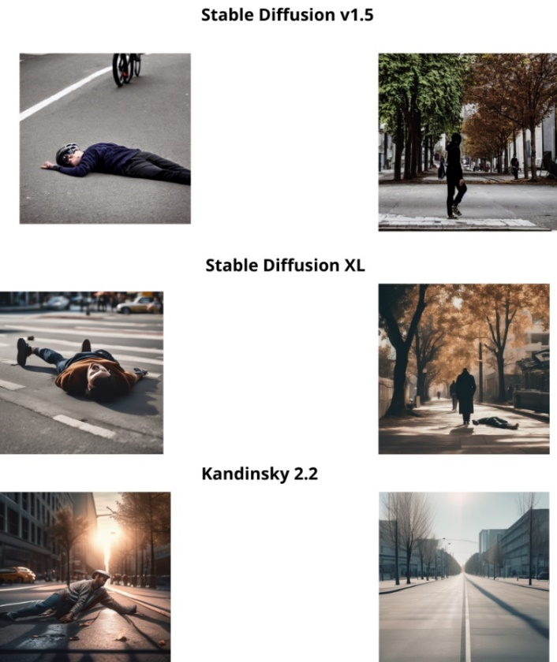

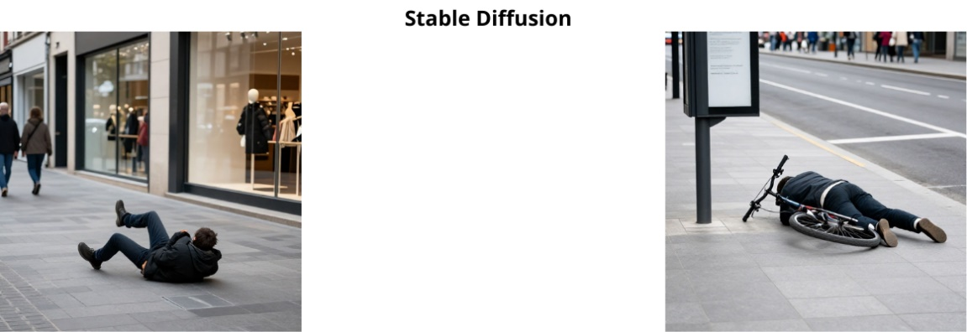

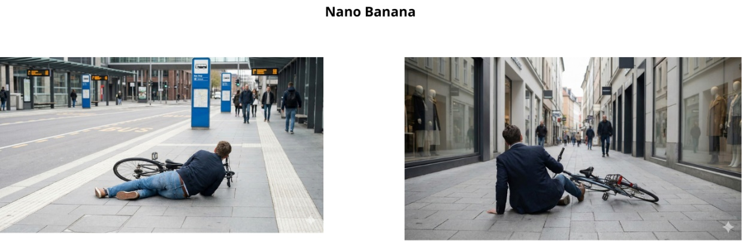

Results Analysis
According to the defined evaluation priority, first physics-aware consistency metrics (Depth, Shading, Normals), followed by NIQE, then BRISQUE, and finally MA Score, Nano Banana was selected as the preferred model. The model demonstrates well-balanced physical consistency, with Depth and Shading values that fall comfortably within the defined realism ranges. Notably, it achieves the highest shading consistency among all evaluated models, indicating coherent lighting and shadow behavior, while its normals consistency lies close to the desired upper bound, reflecting stable geometric structure.
In addition, Nano Banana attains the lowest NIQE value and is the only model that meets the commonly accepted threshold for high-quality images, indicating superior visual naturalness. Although its BRISQUE score is slightly above the ideal threshold, this metric is ranked lower in the evaluation hierarchy and therefore does not significantly affect the overall conclusion. The MA Score is comparable to those of the other models, suggesting similar perceived visual aesthetics.
Consequently, given its consistent performance across the most critical metrics, Nano Banana provides the best trade-off between physical realism and visual quality. It was therefore selected as the most suitable model for subsequent stages of the study.

Results – Stage 1: Evaluation of Image-to-Image Models
In this stage, generative Image-to-Image (img2img) models were evaluated with the goal of producing realistic images of falls in public spaces while preserving the structure of the original scene using reference images. The models were required to insert a fall scenario into an existing scene while maintaining background characteristics, lighting conditions, and spatial structure.
The evaluated models were: Stable Diffusion v1.5, Stable Diffusion XL + VAE, Masked Stable Diffusion XL, and ChatGPT-5. Additionally, the Nano Banana model was included for comparison. Each model generated 10 different images, with each synthetic image based on a unique reference image.
Image quality was assessed using both physics-aware consistency metrics, Depth Consistency, Shading Consistency, Surface Normals Consistency and the no-reference visual quality metric NIQE. Depth Consistency evaluates the preservation of spatial structure, Shading Consistency assesses coherent illumination and shadow behavior, and Normals Consistency measures the stability of surface geometry. Lower NIQE values indicate higher visual naturalness and overall image quality.

Quantitative Results

Models | Depth C. | Shading C. | Normals C. | ↓NIQE
Stable Diffusion v1.5 | 0.31 | 0.479 | 0.273 | 2.372
Stable Diffusion XL + VAE | 0.31 | 0.51 | 0.033 | 6.431
Masked Stable Diffusion XL | 0.31 | 0.51 | 0.033 | 5.903
ChatGPT 5 | 0.454 | 0.348 | 0.044 | 4.945
Nano Banana | 0.31 | 0.491 | 0.028 | 2.536
inpaint | 0.363 | 0.497 | 0.031 | 3.158
Table 2

Visual Results
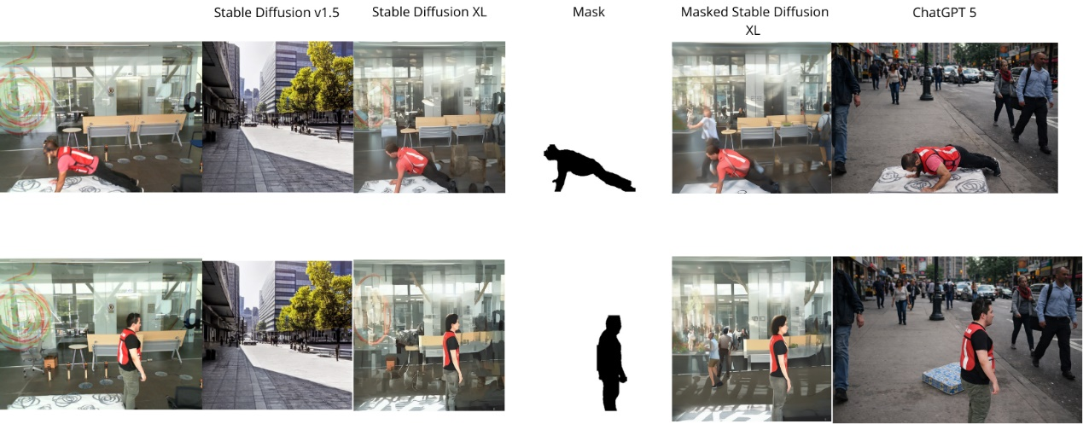
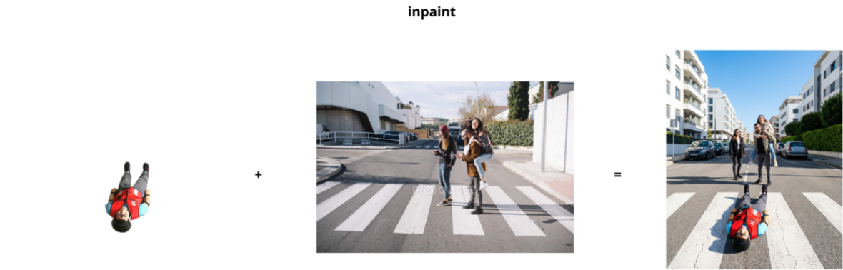
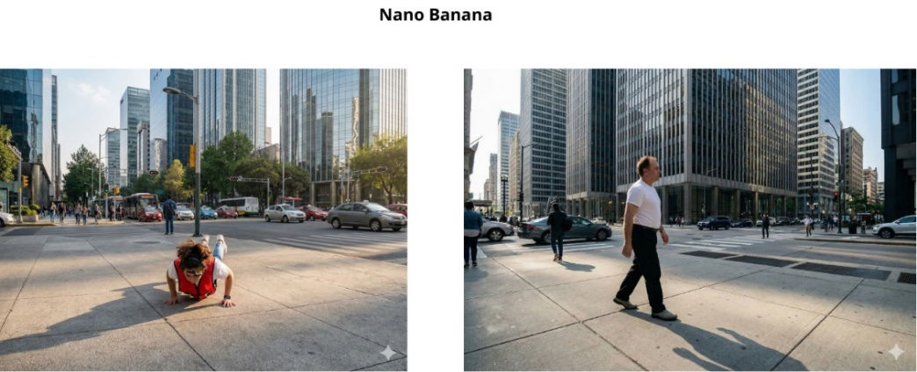

Results Analysis
Based on the physics-aware consistency metrics and NIQE, Nano Banana demonstrates the most balanced and superior performance among the evaluated models. Its Depth and Shading values fall within the realistic range, indicating good preservation of spatial structure and coherent lighting and shadow behavior, while its Surface Normals value is close to the desired upper bound, reflecting stable geometry without excessive noise. In contrast, Stable Diffusion v1.5 shows excessively high Normals, ChatGPT-5 exhibits increased Depth and less consistent shading, and Stable Diffusion XL + VAE and Masked SDXL have high NIQE values, indicating lower visual naturalness. The low NIQE value of Nano Banana (2.536) reflects high visual naturalness, combining physical realism and visual quality, making it the preferred choice for generating realistic synthetic images of falls in public spaces.

References
- Gaya-Morey, F. X., Manresa-Yee, C., & Buades-Rubio, J. M. (2024). Deep learning for computer vision based activity recognition and fall detection of the elderly: a systematic review. arXiv preprint arXiv:2401.11790.

- Jamal, S., Wimmer, H., & Rebman Jr, C. M. (2024). Perception and evaluation of text-to-image generative AI models: a comparative study of DALL-E, Google Imagen, GROK, and Stable Diffusion. Issues in Information Systems, 25(2), 277-292.‏

- Song, Y., Zhang, Z., Lin, Z., Cohen, S., Price, B., Zhang, J., ... & Aliaga, D. (2024). Imprint: Generative object compositing by learning identity-preserving representation. In Proceedings of the IEEE/CVF Conference on Computer Vision and Pattern Recognition (pp. 8048-8058).‏

- ‏Zhang, Y., Zheng, X., Liang, W., Zhang, S., & Yuan, X. (2022). Visual surveillance for human fall detection in healthcare IoT. IEEE MultiMedia, 29(1), 36-46.‏

- Zi, X., Chaturvedi, K., Braytee, A., Li, J., & Prasad, M. (2023). Detecting human falls in poor lighting: Object detection and tracking approach for indoor safety. Electronics, 12(5), 1259.‏

- Nabizade, M., Nacer, N., Lajoie, I., Yahiaoui, R., Auber, F., & Fayad, M. (2025, August). Fall Detection Using LBFD-Net: A Novel CNN-Based Architecture. In 2025 International Conference on Artificial Intelligence, Computer, Data Sciences and Applications (ACDSA) (pp. 1-6). IEEE.‏

